**WEEK-6 REACTJS HANDSON**

1. Create a new React Application with the name “myfirstreact”, Run the application to print “welcome to the first session of React” as heading of that page.

**App.js**

import './App.css';

function App() {

  return (

    <h1>Welcome the first session of React</h1>

  );

}

export default App;

**OUTPUT:**

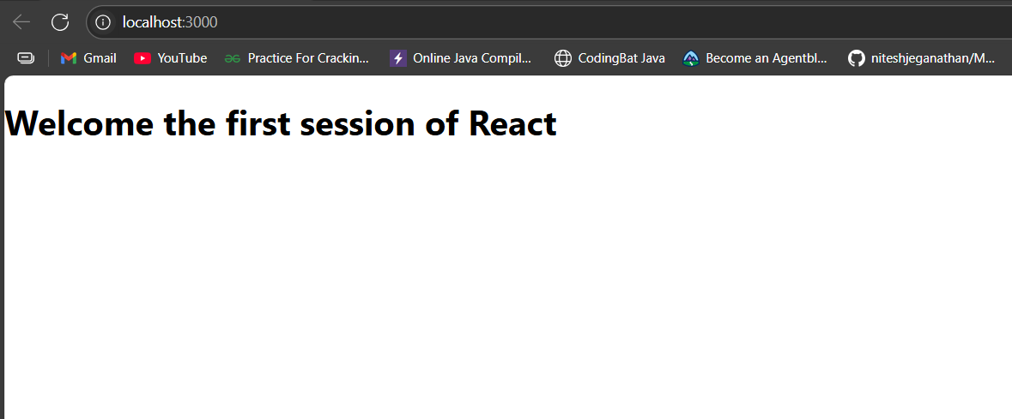

1. Create a react app for Student Management Portal named StudentApp and create a component named Home which will display the Message “Welcome to the Home page of Student Management Portal”. Create another component named About and display the Message “Welcome to the About page of the Student Management Portal”. Create a third component named Contact and display the Message “Welcome to the Contact page of the Student Management Portal”. Call all the three components.

**About.js**

import React, { Component } from 'react';

class About extends Component {

    render() {

        return (

            <div>

                <h3>Welcome to the About Page of Student Management Portal</h3>

            </div>

        );

    }

}

export default About;

**Contact.js**

import React, { Component } from 'react';

class Contact extends Component {

    render() {

        return (

            <div>

                <h3>Welcome to the Contact Page of Student Management Portal</h3>

            </div>

        );

    }

}

export default Contact;

**Home.js**

import React, { Component } from 'react';

class Home extends Component {

    render() {

        return (

            <div>

                <h3>Welcome to the Home Page of Student Management Portal</h3>

            </div>

        );

    }

}

export default Home;

**App.js**

import logo from './logo.svg';

import './App.css';

import Home from './Components/Home';

import About from './Components/About';

import Contact from './Components/Contact';

function App() {

  return (

    <div className="container">

      <Home />

      <About />

      <Contact />

    </div>

  );

}

export default App;

**OUTPUT**  
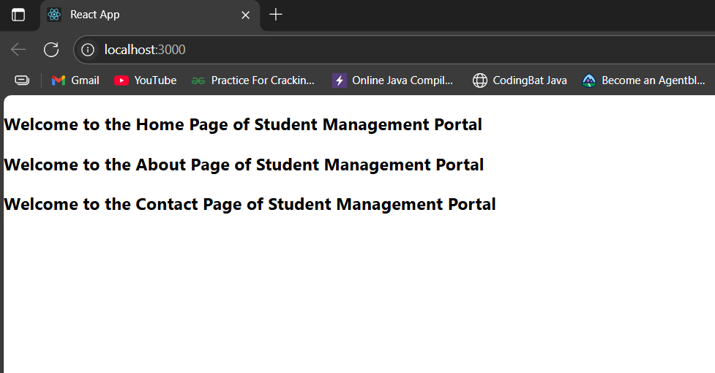

3. Create a react app for Student Management Portal named scorecalculatorapp and create a function component named “CalculateScore” which will accept Name, School, Total and goal in order to calculate the average score of a student and display the same.

**CalculatorScore.js**

import React from 'react';

import PropTypes from 'prop-types';

import '../Stylesheets/mystyle.css'; // go up one level to access Stylesheets

const percentToDecimal = (decimal) => {

  return (decimal * 100).toFixed(2) + '%';

};

const calcScore = (total, goal) => {

  if (!goal || goal === 0) return '0%';

  return percentToDecimal(total / goal);

};

export const CalculateScore = ({ Name, School, total, goal }) => (

  <div className="formatstyle">

    <h1 style={{ color: 'brown' }}>Student Details:</h1>

    <div className="Name">

      <b>Name:</b> <span>{Name}</span>

    </div>

    <div className="School">

      <b>School:</b> <span>{School}</span>

    </div>

    <div className="Total">

      <b>Total:</b> <span>{total} Marks</span>

    </div>

    <div className="Score">

      <b>Score:</b> <span>{calcScore(total, goal)}</span>

    </div>

  </div>

);

CalculateScore.defaultProps = {

  Name: 'Unknown',

  School: 'Not Provided',

  total: 0,

  goal: 100

};

CalculateScore.propTypes = {

  Name: PropTypes.string,

  School: PropTypes.string,

  total: PropTypes.number,

  goal: PropTypes.number

};

export default CalculateScore;

**mystyle.css**

.Name {

    font-weight: 300;

    color: blue;

}

.School {

    color: crimson;

}

.Total {

    color: darkmagenta;

}

.Score {

    color: forestgreen;

}

.formatstyle {

    text-align: center;

    font-size: large;

}

**App.js**

import React from 'react';

import './App.css';

import './Stylesheets/mystyle.css';

import CalculateScore from './Components/CalculateScore';

function App() {

  return (

    <div className="App">

      <CalculateScore

        Name="Steeve"

        School="DNV Public School"

        total={284}

        goal={300}

      />

    </div>

  );

}

export default App;

**OUTPUT:**

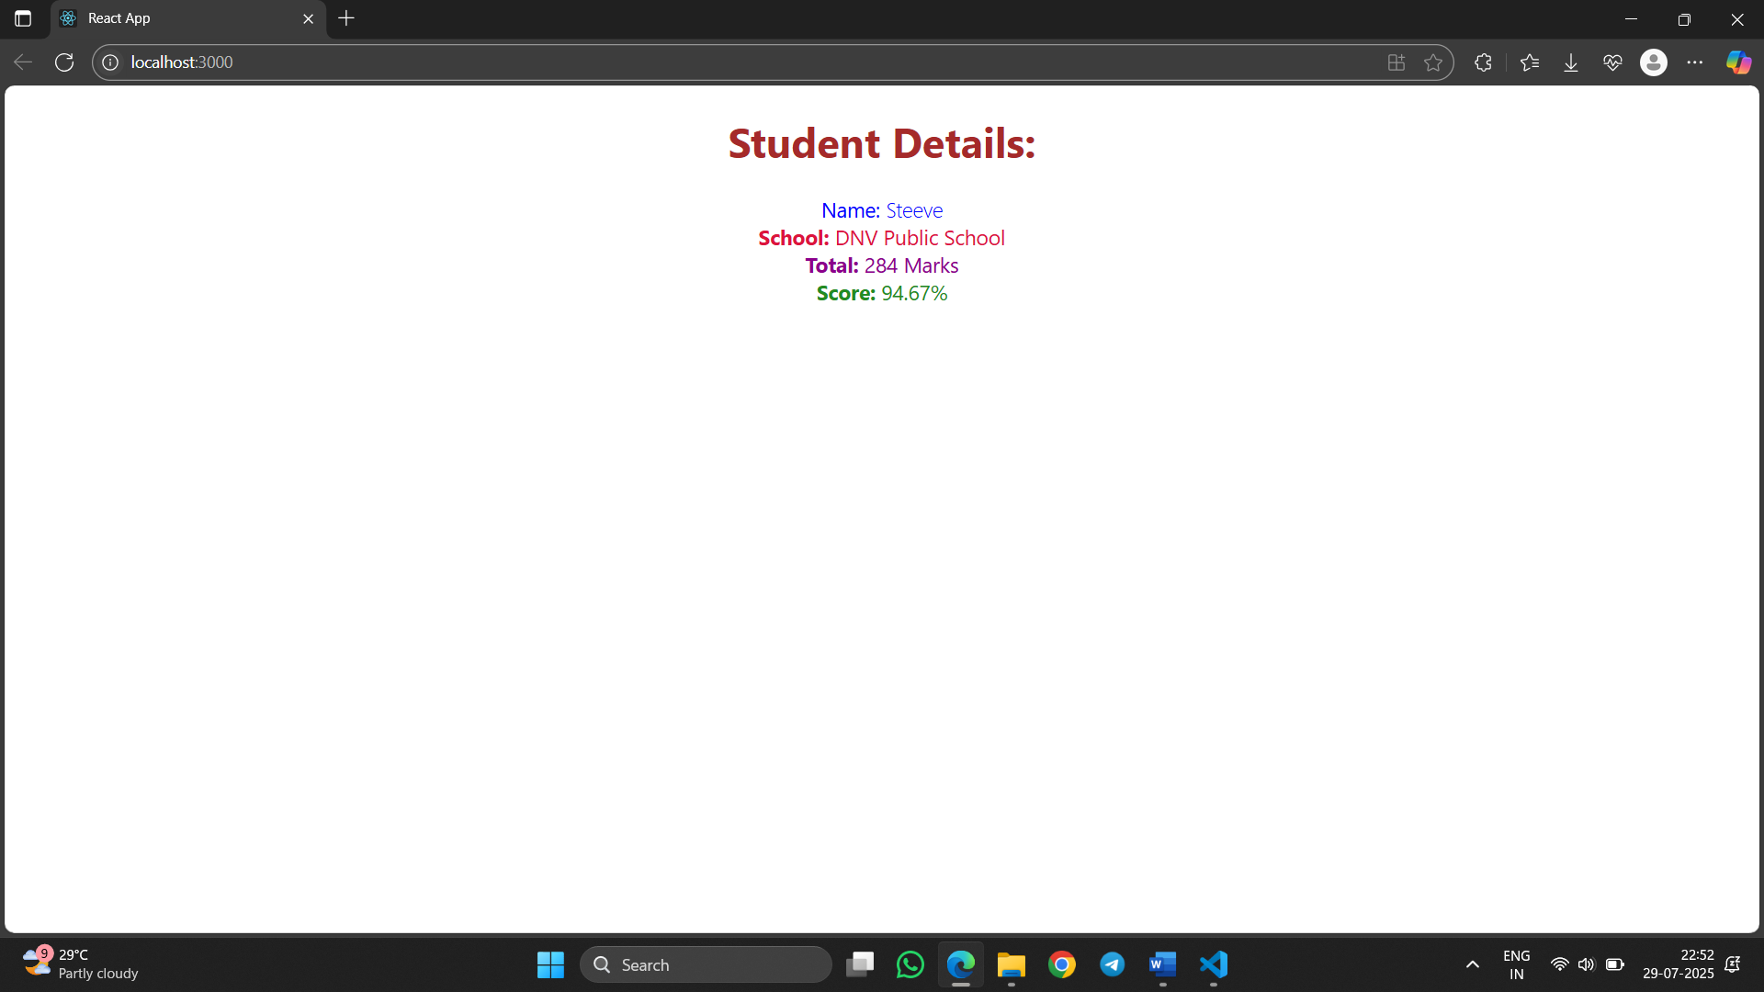

4. Create a new react application using *create-react-app* tool with the name as “blogapp”

Open the application using VS Code

Create a new file named as **Post.js** in **src folder** with following properties

**App.js**

import React from 'react';

import Posts from './Posts';

function App() {

  return (

    <div className="App">

      <Posts />

    </div>

  );

}

export default App;

**Posts.js**

import React, { Component } from 'react';

class Posts extends Component {

  constructor(props) {

    super(props);

    this.state = {

      posts: [],

      error: null

    };

  }

  loadPosts = () => {

    fetch('https://jsonplaceholder.typicode.com/posts')

      .then((response) => response.json())

      .then((data) => this.setState({ posts: data }))

      .catch((err) => this.setState({ error: err }));

  };

  componentDidMount() {

    this.loadPosts();

  }

  componentDidCatch(error, info) {

    alert('Error occurred in Posts component');

    console.error('Error:', error, 'Info:', info);

  }

  render() {

    return (

      <div>

        <h1>Blog Posts</h1>

        {this.state.posts.map((post) => (

          <div key={post.id}>

            <h2>{post.title}</h2>

            <p>{post.body}</p>

          </div>

        ))}

      </div>

    );

  }

}

export default Posts;

**OUTPUT:**

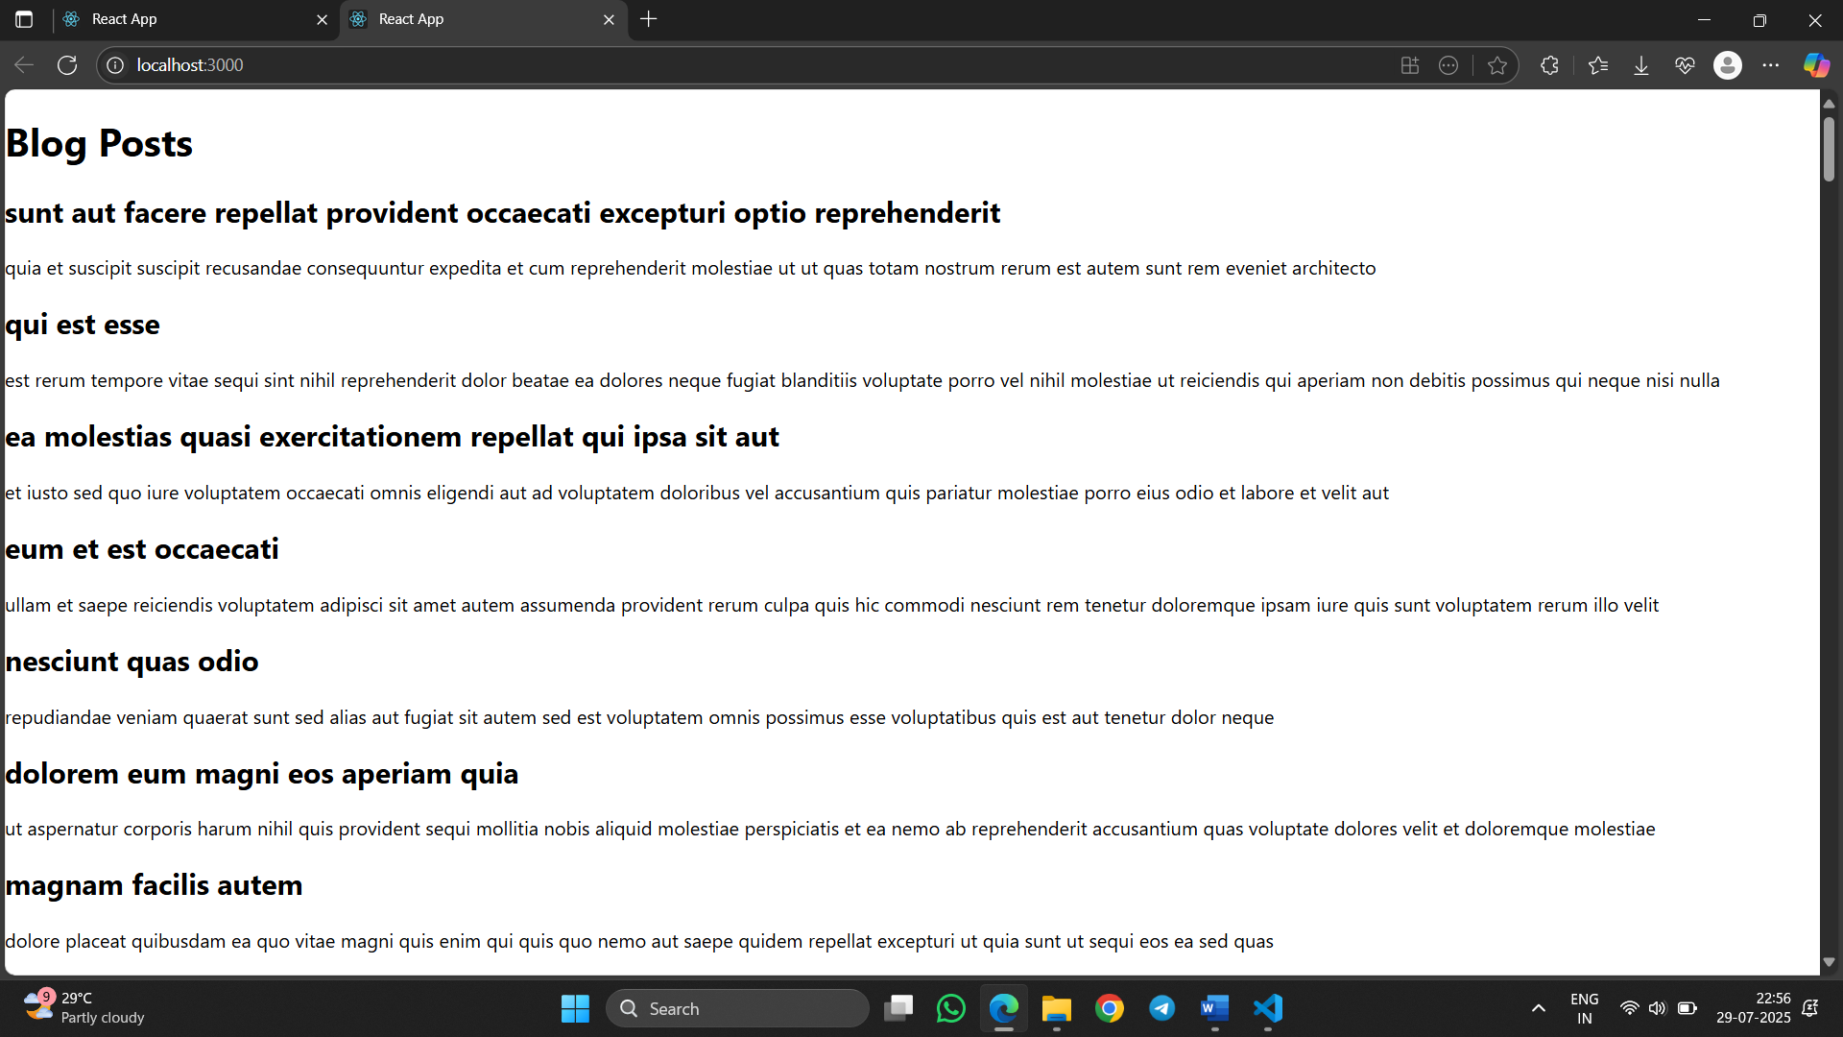

5. My Academy team at Cognizant want to create a dashboard containing the details of ongoing and completed cohorts. A react application is created which displays the detail of the cohorts using react component. You are assigned the task of styling these react components.

Download and build the attached react application.

1. Unzip the react application in a folder
2. Open command prompt and switch to the react application folder
3. Restore the node packages using the following commands

My Academy team at Cognizant want to create a dashboard containing the details of ongoing and completed cohorts. A react application is created which displays the detail of the cohorts using react component. You are assigned the task of styling these react components.

Download and build the attached react application.

1. Unzip the react application in a folder
2. Open command prompt and switch to the react application folder
3. Restore the node packages using the following commands

**Module.css**

.card {

  border: 1px solid lightgray;

  border-radius: 10px;

  padding: 15px;

  margin: 10px;

  width: 250px;

  box-shadow: 2px 2px 8px #ccc;

  display: inline-block;

  vertical-align: top;

}

.status-scheduled {

  color: blue;

  font-weight: bold;

}

.status-ongoing {

  color: green;

  font-weight: bold;

}

.label {

  font-weight: 600;

  display: block;

  margin-top: 8px;

}

.card {

  border: 1px solid lightgray;

  border-radius: 10px;

  padding: 15px;

  margin: 10px;

  width: 250px;

  box-shadow: 2px 2px 8px #ccc;

  display: inline-block;

  vertical-align: top;

}

.status-scheduled {

  color: blue;

  font-weight: bold;

}

.status-ongoing {

  color: green;

  font-weight: bold;

}

.label {

  font-weight: 600;

  display: block;

  margin-top: 8px;

}

**CohortCard.js**

import React from 'react';

import styles from './CohortCard.module.css';

function CohortCard({ name, startDate, status, coach, trainer }) {

  const statusClass =

    status.toLowerCase() === 'scheduled'

      ? styles['status-scheduled']

      : styles['status-ongoing'];

  return (

    <div className={styles.card}>

      <h3 className={statusClass}>{name}</h3>

      <span className={styles.label}>Started On</span>

      <span>{startDate}</span>

      <span className={styles.label}>Current Status</span>

      <span>{status}</span>

      <span className={styles.label}>Coach</span>

      <span>{coach}</span>

      <span className={styles.label}>Trainer</span>

      <span>{trainer}</span>

    </div>

  );

}

export default CohortCard;

**App.js**

import React from 'react';

import CohortCard from './CohortCard';

function App() {

  const cohorts = [

    {

      name: 'INTADMDF10 - .NET FSD',

      startDate: '22-Feb-2022',

      status: 'Scheduled',

      coach: 'Aathma',

      trainer: 'Jojo Jose',

    },

    {

      name: 'ADM21JF014 - Java FSD',

      startDate: '10-Sep-2021',

      status: 'Ongoing',

      coach: 'Apoorv',

      trainer: 'Elisa Smith',

    },

    {

      name: 'CDBJF21025 - Java FSD',

      startDate: '24-Dec-2021',

      status: 'Ongoing',

      coach: 'Aathma',

      trainer: 'John Doe',

    },

  ];

  return (

    <div style={{ padding: '20px' }}>

      {cohorts.map((cohort, index) => (

        <CohortCard key={index} {...cohort} />

      ))}

    </div>

  );

}

export default App;

**OUTPUT:**

